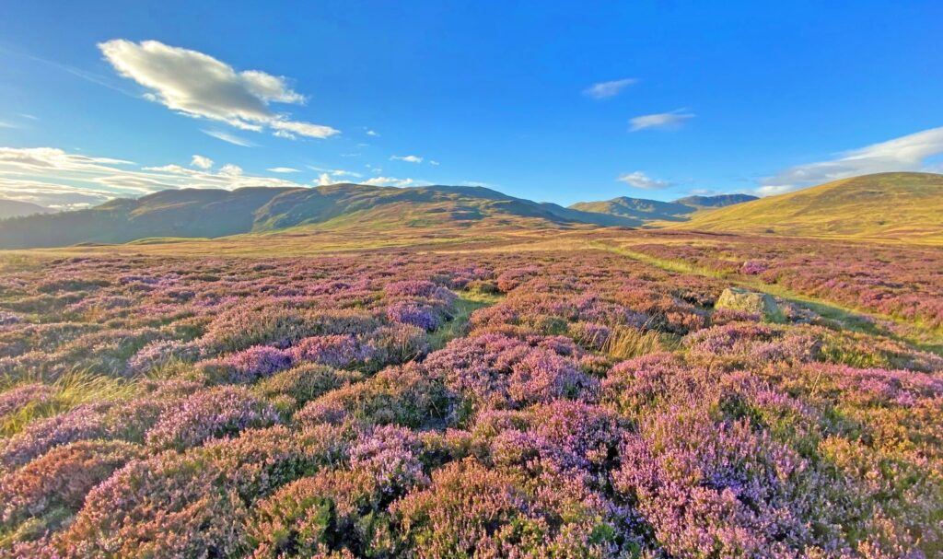
The deer plan at the bottom of this page (in green) has now expired. The current Section 7 agreement effectively sets out the deer plan until summer 2026, with deer culls and target densities overseen by Nature Scot. They also oversee culls in that part of SGDMG outwith the Section 7 area.
The current Section 7 population model, updated in June 2024, can be noted here below:
Section 7 agreed population model- June 2024 version
The challenge for the group and for Nature Scot going forwards is to think about what happens beyond spring 2026, and a plan will need to be developed to inform that. The DMG are currently looking at options for doing this. In the meantime, the following maps and documents, some of which can also be accessed on other pages of this website, are posted here to highlight the structure and nature of the deer management group and some of the issues it faces.
SGDMG Location Map
The following map shows member properties within the SGDMG area, a mixture of private and public owners, with a wide range of management objectives..
SGDMG Members Map
The following map shows the Section 7 area, and how this relates to the Caenlochan SSSI/ SAC site which is the focus of this arrangement.
Caenlochan Section 7 map
The following map shows the SSSI and SAC designated sites of relevance to SGDMG, and also the Corrie Fee National Nature Reserve. There are other designated sites to the north of the Glen Callater beat, but these are not relevant to the main working of SGDMG, and therefore not shown on the map. While Caenlochan SSSI/ SAC has a high profile and dominates the group, the adjacent Glen Callater SSSI and Garbh Choire SSSI have a very similar suite of designated features, and these sites should therefore be considered as a whole. There is also a designated pinewood site to the south west of the DMG area. The SAC designated river tributaries are very dominant within the landscape.
SGDMG Designated Sites map
The Excel spreadsheet here below notes the designated features within the DMG area and their current condition. A significant proportion of features are in Unfavourable, and sometimes declining condition, and herbivore pressure is a key pressure on most of these.
SGDMG Designated features list
A significant proportion of the area is classified as “wildland”, or lies within the Deeside & Lochnagar National Scenic area. The northern part of the DMG also lies within the Cairngorms National Park. All these areas can be noted on the map below:
SGDMG Landscape Designations map
The map below shows the distribution of woodland within the area. The areas shown as red or green are native woodland surveyed 2007-13 as part of the Native Woods of Scotland Survey (NWSS), with the red showing high browsing pressure, and the green showing low or moderate pressure. Some of these evaluations may now be out of date, but it is apparent that the majority (75%) of sites at that time were at low or medium impacts, rising to 83% within the actual Section 7 area. The areas shown in black are other, mostly non native conifer plantations. In addition, a number of woodland planting or regeneration schemes are currently being developed or progressed within the area. These will be detailed once information on these has been collated. The vast majority of woodland within the area lies to the south west, outwith the Section 7 area. Knowing what deer are present within these woodlands is particularly difficult.
SGDMG Woodland Distribution map
The range of open ground habitats present within the area is complex, but the map below shows the distribution of random blanket bog and dwarf shrub heath plots generated by Scottish Natural Heritage in 2014. In general terms, you can see that the dwarf shrub heath is concentrated towards the south west of the area. When combined with the woodland cover there, and the fertile farmland in the glens, this provides a perfect habitat for generating high deer numbers. Further north, much of the area is blank, suggesting grassland based habitats. Most of the blanket bog is concentrated around the centre of the area, and within Caenlochan SSSI/ SAC. The distribution of habitats across the area is useful in trying to understand the deer dynamics.
SGDMG Distribution of BB & DSG habitats
This Excel spreadsheet gives a more detailed breakdown of the habitats present within the SG DMG area, the Section 7 area, and the Caenlochan SSSI/SAC area. The database was collated in 1988, so woodland habitats in particular will now be different, but this information is useful in getting an insight in to the character of each area.
SGDMG Extent of Different Habitats spreadsheet
Finally, the map below shows the distribution of recorded deer- vehicle collisions in and around the area over the period 2000-18. Obviously, there are almost no DVC records within the area itself, but the frequency of accidents in the wider area is obvious, highlighting the presence of deer beyond the DMG area, some of which may be affecting the deer population within SGDMG.
SGDMG DVC Map

East Grampian SA1 (now South Grampian DMG) Deer Management Plan
EG SA1 boundary map
EG SA1 map 1.2
EG SA1 SPA map 1.3
EG SA1 NWSS map 4

